Objectives

- Show one option of port security – setting the maximum allowable MAC addresses
- When you open Packet Tracer:
  - Add a NOTE with your name, class id and the text “LAB3B Port Security”
  - Don’t forget to set Preferences to “BUFFER FILTERED EVENTS” only
  - Edit Simulation filters – show only ICMP
- Create a word DOC file – LAB3A-yourlastname.DOCX – format per guidelines
- Include the following sections in your lab submission
  - Purpose - In your own words, what is the purpose of this lab?
  - Questions – What are the answers to any questions asked in the lab?
  - New Terms/Commands – What new CLI commands or networking terms were introduced?
  - Comments/Reflection

A - Create the Topology
- Launch Packet Tracer on your workstation, and create the below topology.
DO NOT CONNECT PC4 AT THIS TIME.
Connect the switches via each switch’s port G0/1.

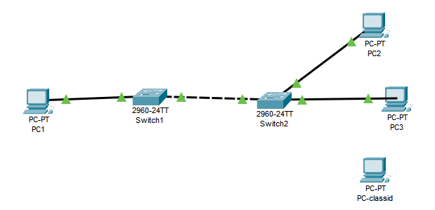

- Note: the fourth PC will be set to your classid, ex: PC162
- Assign IP addresses : PC1=192.168.10.1, PC2=192.168.10.2, etc
- Click the FWD icon to ensure full connectivity.
- Click on PREFERENCES/INTERFACE and turn off SHOW DEVICE MODEL LABELS

B – Setting Port Security on SWITCH0
- Ensure you are on SWTICH1 – which has only one PC connected.
- Add a console PC to the switch so we can execute CLI commands, and name the PC “CONSOLE”
- Configure a secure (hashed) password of “cisco”
- Enter global config mode
- Enter INTERFACE G0/1(to enter specific configuration mode)
- Enter “DO SHOW PORT-SECURITY INTERFACE G0/1” to display the current port security settings

Q1 – What is the function of the “DO” command?

- Enter the following to set a maximum of 3 allowable MAC addresses for the port:
  - switchport mode access
  - switchport port-security
  - switchport port-security maximum 3

Q2 – What do these three commands do?

- Display the port security setting again to verify your changes.

Q3 – Note the violation mode is set to SHUTDOWN. What other options are there?

C – Testing port security

- Leave simulation mode off for this exercise – we’ll use realtime
- Display the port security setting again and make note of the MAXIMUM MAC ADDRESSES and TOTAL MAC ADDRESSES.
- With the fourth PC still disconnected, enter CMD mode on PC1 and ping PC2.
- Display the port security setting again and make note of the MAXIMUM MAC ADDRESSES and TOTAL MAC ADDRESSES.

Q4 – What changed?

- With the fourth PC still disconnected, enter CMD mode on PC1 and ping PC3.
- Display the port security setting again and make note of the MAXIMUM MAC ADDRESSES and TOTAL MAC ADDRESSES.
- Since we haven’t exceeded the maximum number (3) of allowable MAC addresses, there should be no topology change.
Now connect the fourth PC to Switch2- port 24 and ping it from PC1.
- At this point the link between the switches should be disabled. Switch0’s secured port should have done this.
Q5 - Why did it do this now?
- To remedy the problem, enter the commands:
switchport port-security maximum 4
shutdown
no shutdown
- Click on the FWD icon and your network should be back in working order!

Assignment Submissions

- Save the PKT file as L03b-yourlastname.PKT
Complete the sections in the submission document.
- Submit both the DOC file AND the PKT file in iLearn.

- End of Lab -

